Group Activity
Activity 1
Archit: Imagine we're moving kitchen items quickly because the truck's arriving soon. We'd just throw everything into boxes without much care—this is like UDP, where speed matters more than reliability.

Pranika: Exactly, UDP is fast but doesn’t guarantee that everything arrives safely or in order, like streaming videos.

Gitanshi: But if we have more time and care about the order and safety of each item, we’d use TCP—carefully packing and labeling everything.

Jasveena: Yes, TCP ensures everything arrives intact and in the right order, like downloading large files.

Nadia: So, UDP for speed, TCP for reliability. Different scenarios, different protocols!
Activity 2
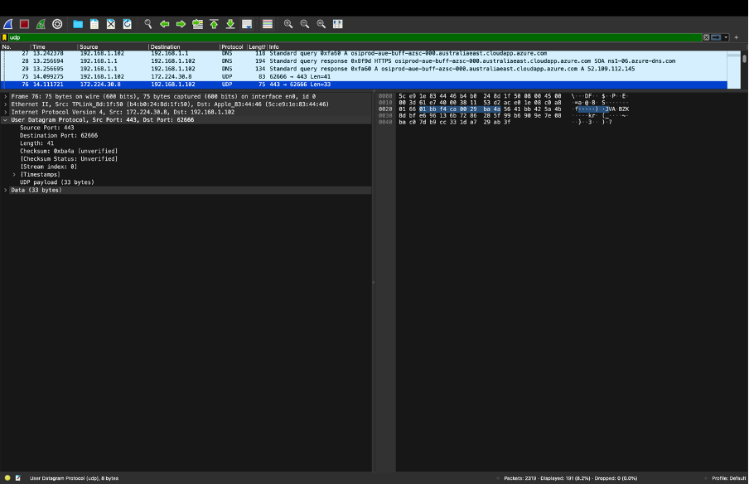
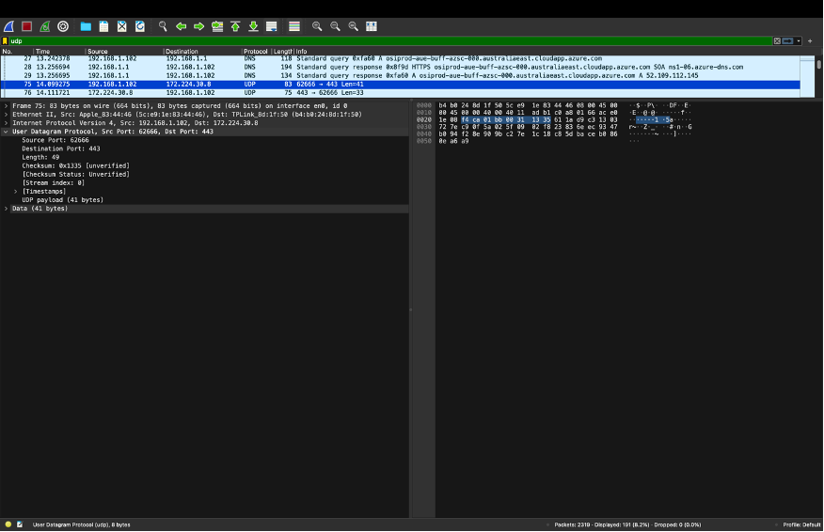

UDP Header Fields:
· Fields: Source Port, Destination Port, Length, Checksum.
· Each Field Length: 2 bytes.
· Total Header Length: 8 bytes.
Length Field:
Indicates: Total length of UDP header + payload.
· Screenshot 1: Length = 49 bytes (8-byte header + 41-byte payload).
· Screenshot 2: Length = 41 bytes (8-byte header + 33-byte payload).
Maximum UDP Payload:
· Theoretical Max: 65,507 bytes.
· UDP Protocol Number:
· Number: 17.
Consecutive UDP Packets:
· Relationship: First packet (source port 62666, destination port 443) is likely a request; second packet (source port 443, destination port 62666) is the response.
Port Numbers Across UDP Packets:
· Varies: Different applications/sessions use different port numbers.

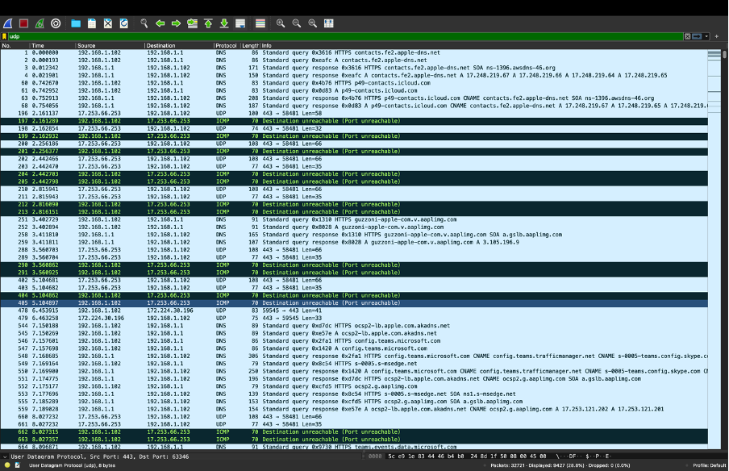
· Observation: UDP packets captured use different port numbers.
· Example: Ports like 58481, 59545, and 63346 are used.
· Explanation: Different applications and sessions use different ports to manage separate data streams.
This confirms that UDP packets from various applications like MSTeams and web browsing don't share the same port numbers.

Activity 3
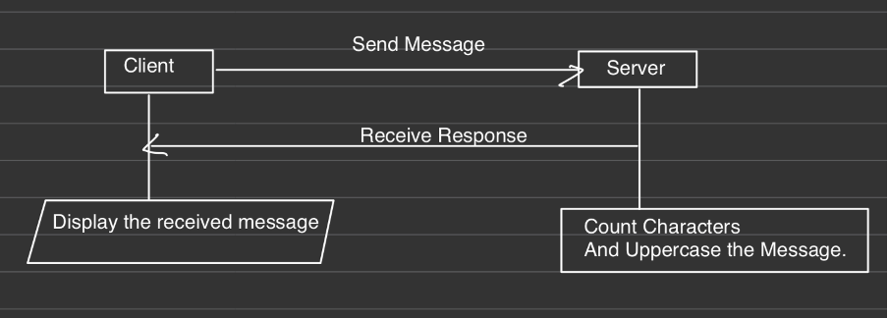

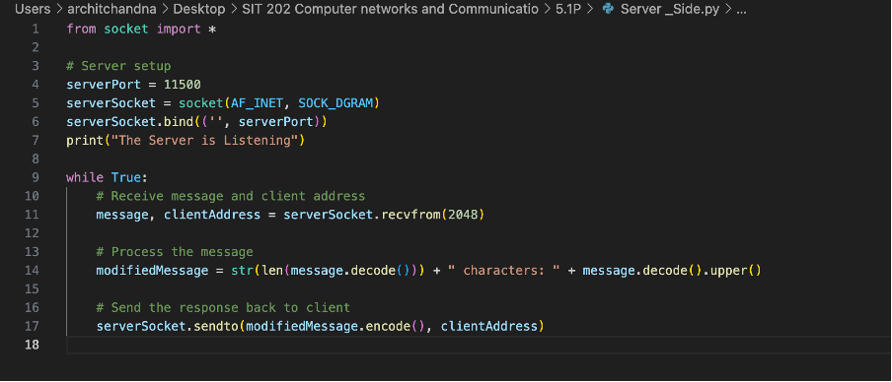
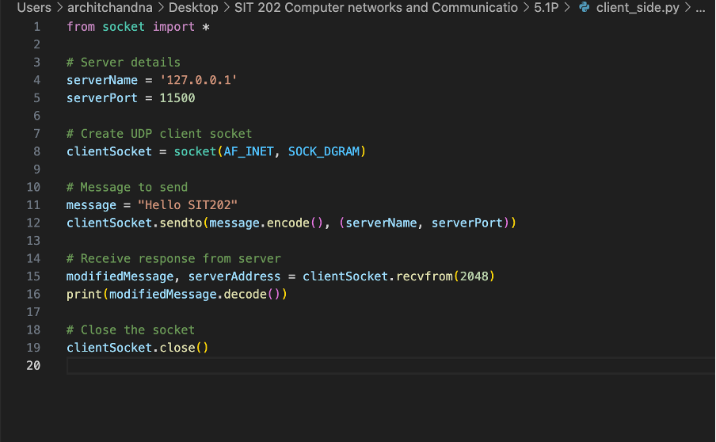
Activity 2
TCP Three-Way Handshake Analysis
1. SYN Packet: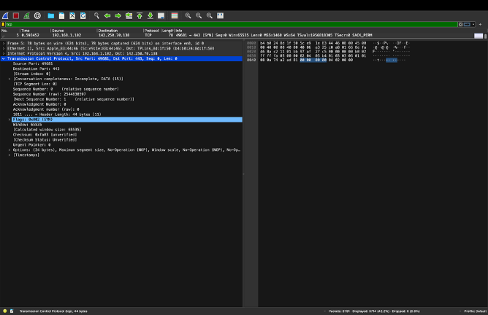
o Source Port: 49681, Destination Port: 443
o Sequence Number: 0
o Flags: SYN (Initiates connection)
o Header Length: 44 bytes
2. SYN-ACK Packet:
o Source Port: 443, Destination Port: 49681
o Sequence Number: 0, Acknowledgment Number: 1
o Flags: SYN, ACK (Acknowledges SYN, responds with SYN)
o Header Length: 40 bytes
3. ACK Packet: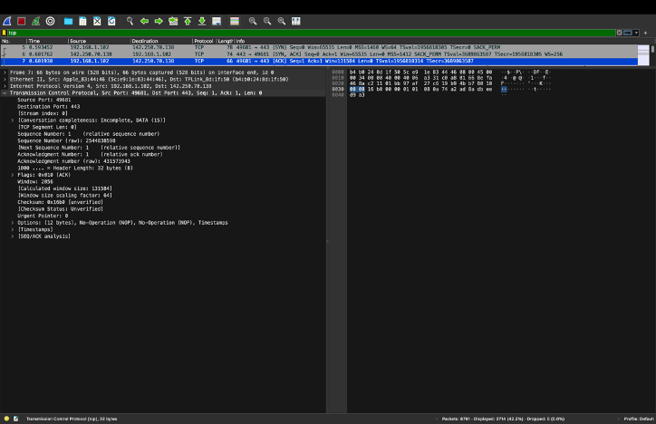
o Source Port: 49681, Destination Port: 443
o Sequence Number: 1, Acknowledgment Number: 1
o Flags: ACK (Finalizes connection)
o Header Length: 32 bytes
Purpose:
- SYN: Initiates connection.
- SYN-ACK: Acknowledges and responds to SYN.
- ACK: Confirms SYN-ACK, establishing the connection.

Activity 3 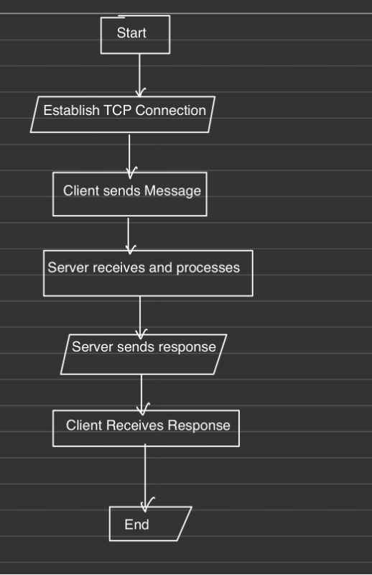
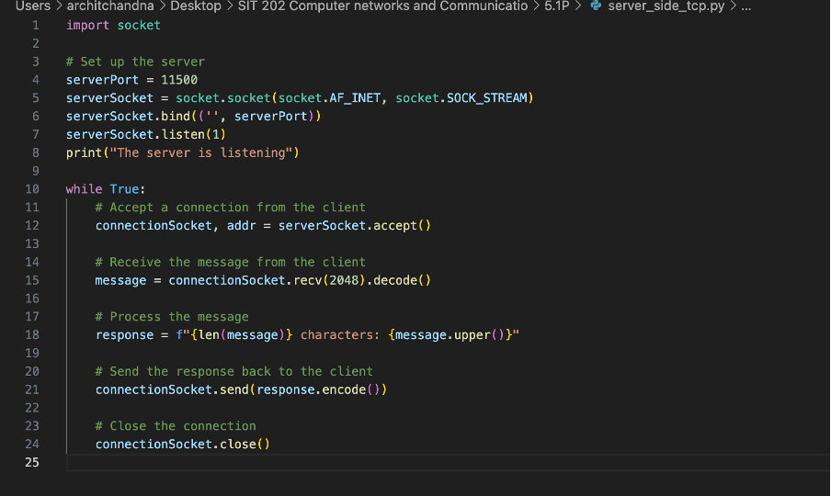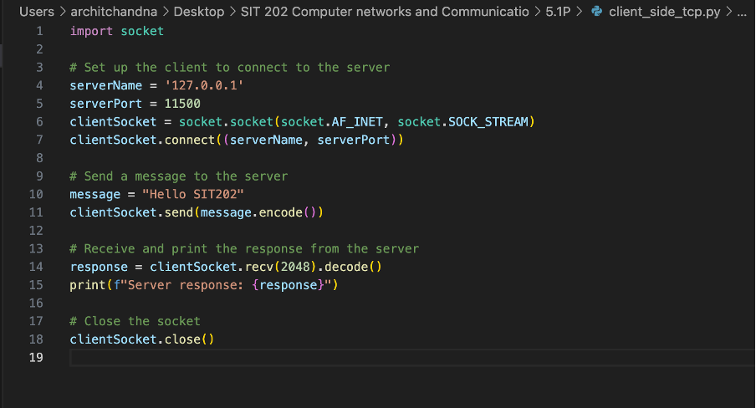

QUESTION:
- Why do we need transport layer protocols?
- Can the Internet survive without transport layer protocols?
ANSWER:
Why Do We Need Transport Layer Protocols?

Transport layer protocols are essential because they:

1. Ensure Reliable Communication: They guarantee that data arrives correctly and in the right order.
2. Handle Errors: They detect and correct errors during transmission.
3. Control Data Flow: They prevent data overflow by managing the rate of transmission.
4. Manage Connections: They establish, maintain, and terminate communication sessions.
5. Segment Data: They break data into manageable pieces and reassemble it at the destination.
6. Direct Data: They use port numbers to route data to the correct application.

Can the Internet Survive Without Transport Layer Protocols?

No, the Internet cannot function effectively without transport layer protocols. They provide the necessary mechanisms for reliable, error-free data transfer, flow control, and proper routing of data to applications. Without them, communication would be unreliable and inefficient.

QUESTION:
Explore different TCP segments in a Wireshark packet capture and identify different header fields used in TCP segments. Note down your answer before you continue.

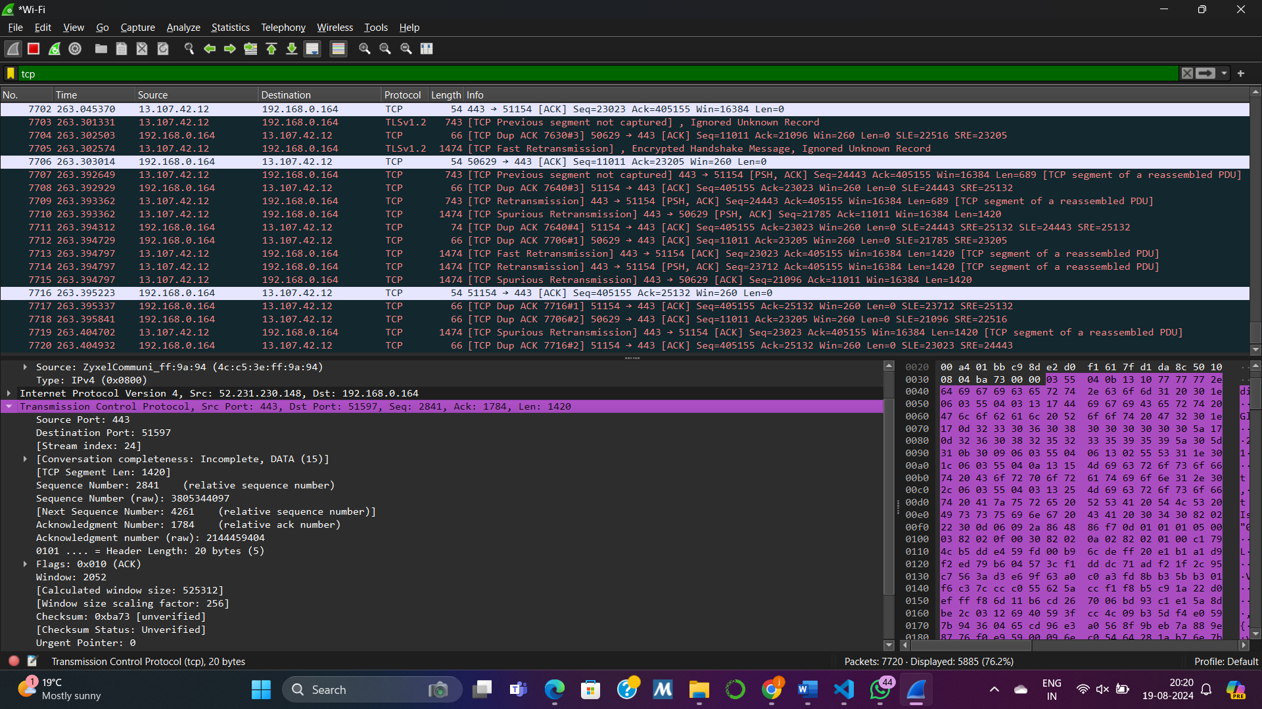
Source port: 443
Destination port: 51597
Sequence number: 2841
Acknowledgement number: 1784
Header lengths: 20 bytes
Flags: 0x010
Window: 2052
Checksum : oxba73
Urgent pointer : 0

QUESTION:
In a Wireshark Packet capture of a network application that uses TCP as the transport layer protocol, can you identify "three-way handshake" and relevant TCP segments with SYN, SYN/ACK, ACK flags are set to 1?
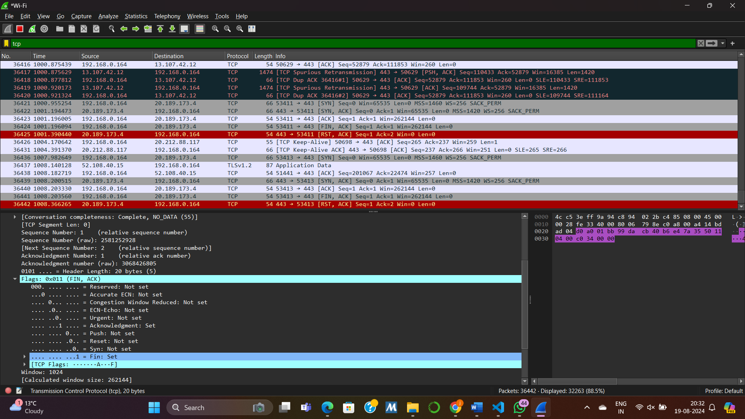

HANDWRITTEN NOTES:
HANDWRITTEN NOTES:
